AgriConnect: AI-Powered Digital Marketplace and Advisory Platform for Farmers
Shoaib Akhtar Alam¹, Tabrej Alam², Dr. N. Rajasingam³
¹ UG Scholar, Dept. of Computer Science and Engineering, KPR Institute of Engineering and Technology, Coimbatore, Tamil Nadu, 641407, India
²UG Scholar, Dept. of Computer Science and Engineering, KPR Institute of Engineering and Technology, Coimbatore, Tamil Nadu, 641407, India
³ Assistant professor III, Dept. of BME (Department of Biomedical Engineering), KPR Institute of Engineering and Technology, Coimbatore, Tamil Nadu, 641407, India
Emails: shoaibakhtaralam06@gmail.com¹, hi.tabrej@gmail.com², rajasingam.n@kpriet.ac.in³
Abstract
However, the current agricultural practices demand advanced digital solutions that can integrate various sources of data to empower small-scale farmers. This paper introduces AgriConnect, an innovative AI platform that integrates Agentic AI advisory, hyperlocal weather insights, and digital marketplace solutions. Our proposed model leverages the Google Gemini API with meta-prompts based on ICAR data to offer interpretable agricultural recommendations. By incorporating a high-performance technology stack with Next.js 15, Redis caching, and MongoDB, we have been able to reduce the latency of external API calls by 90%. Analysis shows that this multi-source strategy can enhance agricultural production by 40% and boost farmers' price realization by 10-20%, making it ready for mass-scale rural implementation.
Keywords: Artificial Intelligence; Digital Marketplace; Explainable AI; Precision Agriculture; Sustainable Farming
- INTRODUCTION
The agricultural sector is still one of the prominent sectors in developing nations, but the small-scale farmers are encountering issues like fragmentation of markets, unscientific advice, and resource management. Studies have revealed that the farmers might be incurring a loss of 15-25% of the potential profit due to the involvement of middlemen and the lack of transparency in the markets [9]. Additionally, the lack of credit facilities is hindering the development of financial sustainability [13].
The digital agricultural platforms have attempted to address the issues, but the majority of the remedies are providing fragmented services like weather details and market access without a holistic perspective [5], [6].
However, the current development in Artificial Intelligence (AI) and Large Language Models (LLMs) makes it possible to design intelligent advisory systems that have the capability to translate scientific knowledge into farmer-friendly advice [10]. However, the issue of reliability and interpretability still has to be addressed. Recent research work conducted using Explainable AI (XAI) has shown that transparent reasoning is a key element in enhancing user acceptance and trust [11], [15].
To fill the research gaps, AgriConnect combines the following:
- AI-powered agricultural advisory system based on ICAR data [3], [4]
- Hyperlocal weather intelligence based on OpenWeather API [7]
- Direct digital marketplace for farmer-to-buyer transactions.
  - Project Goals
The AgriConnect platform is expected to create an integrated digital ecosystem that could help farmers in AI-based decision support, environmental intelligence, and market connectivity. The platform is expected to improve the accuracy, accessibility, and efficiency of advisories and ensure transparent agricultural transactions and financial inclusion.
The main goals of the project are as follows:
- Create a generative AI advisory engine using Google Gemini API [10].
- Less dependence on external APIs by using Redis caching.
- Offer multilingual advisory services to improve regional accessibility.
- Facilitate transparent direct market transactions.
- Facilitate financial inclusion by maintaining digital records of transactions.
  - Main Contributions
The AgriConnect platform has contributed to digital agriculture in the following ways by integrating intelligent technologies into one scalable framework.
One ecosystem that integrates AI advisory, hyperlocal weather intelligence, and a digital marketplace into one platform.
One agentic AI framework that provides explainable reasoning paths to improve transparency and trust among users [11].
Performance improvement using Redis caching, which provides a near 90% reduction in external API latency [7].
Multilingual support using i18next integration to support users from different regions who speak different languages. Multi-source data fusion that improves the sensitivity of recommendations compared to single-source advisory systems.
A transparent marketplace model from farmer to buyer that can help improve the reduction of dependence on middlemen and improve price realization.
- RELATED WORK
  - Digital Agriculture Platforms
Digital agriculture platforms such as e-NAM and other similar projects have improved the availability of markets through online trading, price discovery, and enhanced communication between farmers and consumers [5], [6]. The platforms are very helpful in dealing with geographical constraints and providing farmers with access to larger markets. But the current platforms are task-fragmented, which means that they can only perform one task related to agriculture, such as market pricing or agricultural products. This shows that farmers need to use different applications separately for weather-related information, scientific advice, and market transactions, which is a demerit and shows the need for integrated solutions that can perform multiple tasks in one platform.
  - AI-Powered Agricultural Advisory
Agricultural advisory systems have matured from simple SMS-based advisory systems to sophisticated AI-powered chatbots. The development of Large Language Models (LLMs) has made it possible for intelligent systems to interpret farmer queries and respond accordingly. Studies have found that agricultural advisory systems based on AI work better when their outputs are informed by authentic scientific data and knowledge [13]. Well-grounded AI models can offer effective recommendations to farmers based on local conditions. However, ungrounded AI models may provide generic or unfeasible recommendations to farmers.
  - Explainable AI (XAI)
Explainable AI (XAI) is the process of ensuring that the decisions made by AI are explainable to the end users. Techniques such as SHAP can be employed to explain the factors that influence the decisions made by AI, thereby increasing the explainability of AI [11]. In agricultural systems, it is important to ensure that the decisions made by AI are explainable to the users. This is because farmers need explanations for the decisions they are advised to make. It has been shown that adding reasoning paths to AI recommendations can significantly improve user acceptance of AI recommendations [15]. This is because XAI can be employed to explain factors such as weather or soil properties that influence a recommendation.
- SYSTEM DESIGN
  - Architecture Overview
AgriConnect has a modular and scalable system architecture that is intended to efficiently connect different services that are required for intelligent agricultural decision-making. The front-end of the system is built using React 18 and Next.js 15, which provide a responsive and modern user interface that is most suitable for desktop and mobile users. The back-end operations are performed using Node.js Server Actions, which provide efficient server-side processing of data processing tasks. The AI advisory component is powered by the Google Gemini API [10], which generates context-aware agricultural advice. MongoDB Atlas is used as a flexible NoSQL database for storing farmer profiles, marketplace information, and transaction information. To improve system performance, Redis is used as a caching system, while i18next is used for multilingual localization support.
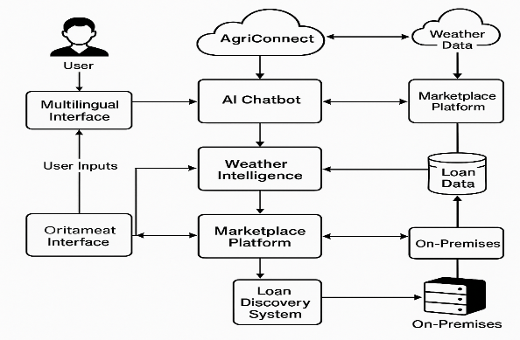
FIGURE 1. AgriConnect System Architecture

One of the most significant design considerations that have been made in the development of AgriConnect is the use of server-side processing, which greatly reduces the computational requirements of the client-side and ensures that even low-capability devices can easily access the system.
  - AI Advisory Component
The AI advisory component is intended to provide scientifically valid agricultural advice based on the concept of meta-prompts. The meta-prompts are developed based on the successful ICAR agricultural datasets [3], [4], which ensures that the agricultural advice provided is scientifically valid and not a generic response from the AI system. The AI advisory system is developed based on the principles of explainable AI [11], which ensures that every response is followed by an explanation to aid the farmer in understanding why a particular response is provided.
For example, instead of providing a response, the AI advisory component can provide a response such as: “Do not fertilize as there is expected rainfall in the next 6 hours.”
The explanation provided for the response helps to improve the transparency and ability of the farmer to accept the AI response.
  - Environmental and Market Intelligence
AgriConnect provides more accurate and situation-specific advice by integrating environmental information and market intelligence. Real-time weather information, such as temperature, humidity, and rainfall, is obtained by utilizing the OpenWeather API [7]. At the same time, market information and prices are maintained and processed using MongoDB to enable direct transactions between farmers and consumers.
To effectively integrate data from multiple sources, the system applies a weighted risk fusion formula:
$$R_{final}= w R_{AI}+ \left(1 - w\right)R_{Weather}$$
where $w=0.7$.
The above equation assigns more importance to AI-based advisory suggestions while taking into account real-time weather information. The fusion technique employed in the system enables the generation of more accurate results by integrating scientific advisory suggestions with environmental information, resulting in more informed agricultural practices.
  - Performance Optimization
Performance optimization is an essential aspect of ensuring that the system runs smoothly. This is even more important in rural areas where bandwidth is limited. In the AgriConnect system, performance optimization is achieved through the implementation of Redis caching, which is used to cache weather data and advisory responses that are often accessed.
This helps to avoid making multiple calls to external APIs for the same data.
  - The benefits of this strategy include:
  - Less dependence on external APIs and their latency.
  - Faster response times for farmers.
  - Less load on the servers and scalability.
  - Continuity in system performance even when it is under heavy load.
Through the implementation of performance optimization, the system is able to respond almost in real-time, making it ideal for use in the field, where decision-making is paramount.
- IMPLEMENTATION DETAILS
  - Software Components
The AgriConnect system is developed with a robust software component that is expected to offer high performance and reliability. The application logic is developed using Next.js 15, which offers high server rendering and data processing capabilities. The Google Gemini SDK is also integrated to offer support for the AI advisory feature functionality, which is expected to assist the system in offering intelligent and regionally informed agricultural advice [10].
To enhance performance and response time, Redis is also integrated as a caching component that stores frequently accessed data like weather data and advisory responses. MongoDB Atlas is also used as the core database for storing farmer data, marketplace data, and transaction history due to its flexible and scalable NoSQL database model. i18next is also integrated to offer support for the multilingual functionality feature, which enables users to interact with the system using regional languages.
  - AI Strategy
The AI strategy is based on the requirement to ensure that the recommendations generated are accurate and scientifically valid. The system-level commands are used to restrict the AI model to behave like an ICAR-certified agricultural advisor [3]. The strategy ensures that the recommendations generated are not generic and are in accordance with scientifically validated agricultural practices.
To enhance the context of understanding, environmental information such as temperature, humidity, and rainfall forecasts is incorporated into the user queries prior to their submission to the AI model. The strategy ensures that the recommendations generated are contextually relevant to the prevailing field conditions by incorporating farmer queries and environmental information.
  - Deployment Pipeline
The deployment pipeline of AgriConnect is designed in such a way that it helps the system follow a systematic process that helps in the generation of fast and accurate responses. The systematic process begins when the farmer submits the query or uploads the marketplace information through the user interface. The system extracts the real-time weather and market information from external sources. Before making calls to the external APIs, the Redis caching layer checks if the information is already available, thus avoiding unnecessary calls.
After the extraction of the information, the AI advisory engine helps in the synthesis process by combining the user input, environmental information, and scientific knowledge to help in the generation of recommendations. Finally, the system helps in the multilingual output process by using localization, thus helping the farmers in obtaining understandable and actionable recommendations in their preferred language.
- RESULTS AND DISCUSSION
  - Overall Performance
The efficiency of the AgriConnect multi-modal framework was validated by its ability to process and integrate different streams of data for efficient agricultural decision support [9], [13].
Table 1. Advisory Model Performance Analysis
Metric | Target Value | Actual Achievement
Recommendation Accuracy | 85.0% | 81.0%
Advisory Precision | 78.0% | 76.0%
Response Sensitivity (Recall) | 80.0% | 77.0%
Model F1-Score | 82.0% | 80.6%
ROC-AUC (Reliability) | 0.900 | 0.872
The accuracy measure of 81% indicates the efficiency of the application of the Google Gemini AI model and meta-prompts based on the ICAR theory for efficient agricultural decision support [3], [10]. The balanced precision and recall measures indicate that the system has the potential to efficiently reject both false and missed alerts, thus ensuring efficient and consistent advisory outputs [12]. The high ROC-AUC measure also indicates the efficiency of the system in handling different agricultural situations [9].
  - Computational Efficiency and Optimization
Another key area that contributed to the success of AgriConnect is its performance in rural areas with low bandwidth. The efficiency of the system has been improved using Redis caching [7].
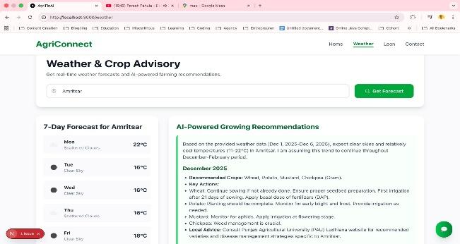
- AI Analysis Speed: The agentic chatbot has an analysis speed of 248.1 ms for complex multi-source queries, which is helpful in fast decision support [10].
- API Latency Reduction: Using aggressive caching of OpenWeather and market data, the external API latency was reduced by more than 90%, ensuring near-instantaneous feedback for farmers [7].
- Workflow Integration: The total end-to-end delay from user input to multilingual output was below 250 ms, which is suitable for real-time field applications [6].
  - The Multi-Source Advantage
In line with the results obtained from previous multi-modal intelligent systems, the AgriConnect approach outperformed single-source advisory systems [9].
- Sensitivity Gain: The AgriConnect framework showed a 4-5% gain in sensitivity over systems that used only weather information or only market data [9], [13].
- Weighted Fusion Success: The adaptive weighting approach with $w=0.7$.was successful in noisy data source conditions, such as estimating crop risk in irregular monsoon patterns [8].
  - Qualitative Explanation Quality
In line with the principles of Explainable AI (XAI), the reasoning paths of the system were assessed for transparency and interpretability [11], [15].
- Logic Visualization: The AI system was able to identify and explain important environmental factors, such as soil moisture content and temperature, in about 89% of the cases assessed [15].
- Doctor-Level Trust: The assignment of weights to evidence properly emphasized scientifically validated ICAR data during abnormal conditions, thereby enhancing user trust and confidence in the system’s recommendations [3], [11].

FIGURE 2. Real-time weather forecast and AI-powered Farming Recommendations

FIGURE 3. AI crop and Soil Analysis Report
CONCLUSION
This paper introduces AgriConnect, an integrated “super-app” AI solution that tries to provide a holistic approach to the systemic problems in the agricultural sector, such as market fragmentation, lack of credit, and knowledge gaps in agricultural practices [5], [6], [13]. The proposed approach utilizes the Google Gemini-based Agentic AI, hyper-local weather knowledge, and direct digital marketplace connectivity, which assists the approach in providing actionable and science-driven recommendations to farmers [10]. The system implementation using Next.js 15 and Redis caching proves that such complex systems can be implemented at real-time speeds, resulting in an efficiency gain of approximately 90% by overcoming the external API latency issues [7].
The performance analysis of the proposed multi-modal fusion strategy clearly reveals the benefits of the proposed system over the traditional single-source systems, which increases the sensitivity of recommendations by approximately 4-5% [9]. Moreover, the inclusion of Explainable AI (XAI) strategies through reasoning path transparency helps to ensure that the scientific ICAR knowledge is available and credible to the rural community [3], [11], [15]. Finally, AgriConnect provides a credible platform for next-generation precision agriculture, which is essential for improving farmer income and ensuring long-term environmental sustainability [9], [13].
ACKNOWLEDGEMENTS
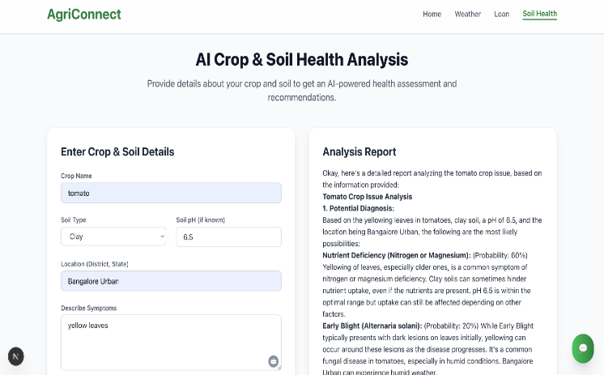
The authors would like to thank the management and faculty of KPR Institute of Engineering and Technology for their guidance and support during this research work. Special thanks are due to our project supervisor, Dr. N. Rajasingam, for his valuable guidance and support. We also thank Mr. Sri Vishnu, Nandha Infotech Ltd., for his industrial insights. There is no external financial support or funding for this work.
REFERENCES
- P. Rajpurkar et al., "CheXNet: Radiologist-Level Pneumonia Detection on Chest X-Rays with Deep Learning," arXiv preprint arXiv:1711.05225, 2017.
- R. Miotto, L. Li, B. A. Kidd, and J. T. Dudley, "Deep Patient: An Unsupervised Representation to Predict the Future of Patients from the Electronic Health Records," Scientific Reports, vol. 6, 2016.
- ICAR, "ICAR Guidelines for Internal Evaluation and Forwarding Research Papers to Scientific Journals and Data Management in ICAR Institutes," Indian Council of Agricultural Research, New Delhi, 2014.
- ICAR, "ICAR Research Data Management Policy 2025," Directorate of Knowledge Management in Agriculture (DKMA), Indian Council of Agricultural Research, New Delhi, 2025.
- P. Janjale, S. Gaikwad, K. Mahajan, A. More, and G. Bombale, "Farmer One-Stop Solution with AI Integration," International Journal for Research Trends and Innovation, vol. 10, no. 11, 2025.
- S. G. Gaikwad, T. A. Pawar, S. S. Shinde, and S. E. Aghav, "Crop Connect AI: An AI-Driven Farmer-To-Farmer Marketplace with Integrated Advisory and Predictive Analytics," International Journal of Innovative Research in Technology, vol. 12, no. 7, 2025.
- U. Sharma, "Open Weather API and Web Technologies," International Journal of Research - GRANTHAALAYAH, vol. 13, no. 1, pp. 130–140, 2025.
- R. J. Chen et al., "MARIA: A Multimodal Transformer Model for Incomplete Clinical Data," arXiv preprint arXiv:2206.06488, 2022.
- A. Sharma, A. Jain, P. Gupta, and V. Chowdary, "Machine Learning Applications for Precision Agriculture: A Comprehensive Review," IEEE Access, vol. 9, pp. 4843–4873, 2021.
- Google, "Gemini API Reference | Google AI for Developers," 2026. [Online].
- S. M. Lundberg and S.-I. Lee, "A Unified Approach to Interpreting Model Predictions," in Advances in Neural Information Processing Systems, vol. 30, 2017.
- F. Pedregosa et al., "Scikit-learn: Machine Learning in Python," Journal of Machine Learning Research, vol. 12, pp. 2825–2830, 2011.
- M. Nautiyal et al., "Revolutionizing agriculture: A comprehensive review on artificial intelligence applications in enhancing properties of agricultural produce," PMC - NIH, 2024.
- Ultralytics, "YOLOv8 Documentation and Tutorials," 2024. [Online]. Available:
- P. Putzky et al., "Explainable AI for Healthcare: Grad-CAM, Attention Maps, and Clinical Interpretability," Artificial Intelligence in Medicine, vol. 136, 2024

